Use of inverters in combination with Dertec Stainless Steel AC motors.

AC motor speed is based on the number of poles of the motor winding and the frequency of the AC voltage applied. In order to change the speed, AC controllers ( frequency inverters ) are used to change the frequency.
Changing the 50 Hz signal to DC and back to AC allows the inverter to supply a controllable frequency and voltage.
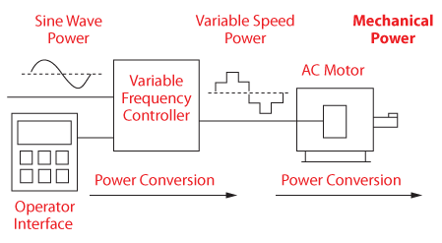
Basic rules when using an inverter with Dertec Stainless Steel AC motors:
- Above 50/60 Hz the torque decreases, please see below graphic.
- For non ventilated motors ( TENV) the controlled frequency setting should be
between 20 and 70 Hz.
- For self ventilated motors ( TEFC) the frequency setting should be between 40 Hz and 70 Hz, in order to keep the fan operating at a safe speed to cool down the motor.
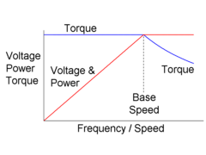
Important notice :
Due to the motors efficiency curve at lower speeds, the motor will generate more heat when controlled at lower frequencies.
To achieve the best efficiency performance we strongly advice to optimize the gear ratio to reach the desired output speed.

Due to the motors load curve we advise to optimize the motor + gear ratio’s configuration in order to reach desired output torque.
If the drive is running at low load capacity ( partial load) it will, due to it’s efficiency at partial load, generate more heat. In some occasions it could be a solution to consider the use of a Dertec Signature line PM Synchronous motor. Please feel to contact our sales department.

